**VISVESVARAYA TECHNOLOGICAL UNIVERSITY**

Jnanasangama, Macche, Santibastwada Road

Belagavi-590018, Karnataka



**A**

**Mini Project Work (18EC6ICMPR) Report**

on

**IMPLEMENTATION OF BASIC PROCESSOR UNIT**

*Submitted in partial fulfilment of the requirement for the degree of*

**Bachelor of Engineering**

*in*

**Electronics & Communication Engineering**

*by*

**1DS18EC156 : VISHVENDRA SINGH**

**1DS18EC153 : TANVI VIJAY**

**1DS18EC144 : SAURABH SINGH**

**1DS18EC143 : SAMEER GAUTAM**

Under the guidance of

**Prof. A. Rajagopal**

Mini Project Guide

Associate Professor, ECE Dept., DSCE, Bengaluru



**Department of Electronics & Communication Engineering**

(An Autonomous College affiliated to VTU Belgaum, accredited by NBA & NAAC)

Shavige Malleshwara Hills, Kumaraswamy Layout,

Bengaluru-560078, Karnataka, India

**2020-21**

# Certificate

Certified that the Mini project work entitled “Implementation of Basic Processor unit” carried out by “1DS18EC156 : VISHVENDRA SINGH, 1DS18EC153 : TANVI VIJAY, 1DS18EC144 : SAURABH SINGH and 1DS18EC143 : SAMEER GAUTAM” are bonafide students of Dayananda Sagar College of Engineering, Bangalore, Karnataka, India in partial fulfilment for the award of Bachelor of Engineering in Electronics & Communication Engineering of the Visvesvaraya Technological University, Belagavi, Karnataka during the academic year 2020-21. It is certified that all corrections / suggestions indicated for Mini project work have been incorporated in the report deposited to the ECE department, the college central library & to the university. This Mini project report (18EC6ICMPR) has been approved as it satisfies the academic requirement in respect of project work prescribed for the said degree.

**________________________________ _________________________**

Dept. Project Coordinator Convener Project Guide

Dr. Roopa M Prof. A. Rajagopal

**__________________________ ________________________**

Head of the Department Dr. C.P.S. Prakash

Dr. T.C.Manjunath Principal

External Project Viva-Voce

Name of the project examiners:

1 : Signature : _____________________

2 : Signature : _____________________

# Declaration

Certified that the Mini project work entitled, “Implementation of Basic Processor unit” is a bonafide work that was carried out by ourselves in partial fulfilment for the award of degree of Bachelor of Engineering in Electronics & Communication Engg. of the Visvesvaraya Technological University, Belagavi, Karnataka during the academic year 2020-21. We, the students of the Mini project group/batch no. C-15 hereby declare that the entire Mini project work has been done on our own & we have not copied or duplicated any other’s work. The results embedded in this Mini project work report has not been submitted elsewhere for the award of any type of degree.

Student Name : Vishvendra Singh USN : 1DS18EC156

Sign : _____________________

Student Name : Tanvi Vijay USN : 1DS18EC153

Sign : _____________________

Student Name : Saurabh Singh USN : 1DS18EC144

Sign : _____________________

Student Name : Sameer Gautam USN : 1DS18EC143

Sign : _____________________

Date :

Place : Bengaluru -78

**Abstract**

Digital processors are built from very large scale integration circuits and the software to design them is only available to the manufacturers themselves. There is a need to design a central processing unit using large, medium and small scale integration circuits which can be used as a teaching aid in computer architecture and design. In this mini-project a simulation model of a basic processor is designed using arithmetic logic unit, control finite state machine unit, multiplexer unit and registers as ­­building blocks with their interconnections. The presented digital processor is of 32-bit incorporating four instructions. The design and simulation is based on Intel Quartus Prime software. The circuit is capable of modeling the functional and timing behavior of the digital processor to use instructions in the groups of arithmetic, shift and program control. A 3-bit input was used for selecting up of the opcodes and imputing data to the digital processor through the input port. Verilog hardware descriptive language and very high speed hardware descriptive language can be used since they offer more tools for design.

**Table of Contents**

Title sheet 1

Certificate 2

Declaration 3

Abstract 4

Table of contents 5

|  |  |
| --- | --- |
| Chapter 1: Introduction | 6 |
| Chapter 2: Literature survey | 10 |
| Chapter 3: Methodology | 14 |
| Chapter 4: Block diagram and Implementation | 18 |
| Chapter 5: Results and Discussions | 20 |
| Chapter 6: Conclusion and Future work | 24 |
| Chapter 7: References | 26 |

**CHAPTER 1 : INTRODUCTION**

**1.1 BACKGROUND:**

Microprocessors have been recognized as important tools by electronic and system designers. As more and more designers get familiarized with the capabilities of the microprocessor, the number of microprocessor-based applications will increase very rapidly. Microprocessors are the result of the semi-conductor industry’s effort to accommodate an ever increasing number of transistors in a single integrated circuit so as to implement a given function with a smaller number of chips than any previous devices. The central processing unit is the major component of a microprocessor. Today’s microprocessor technology has increased the speed of operation due to the very large scale integration of components in a single chip. The central processing unit (CPU) performs a variety of functions as dictated by the type of instructions that are incorporated in the computer in order to fetch and execute data and instructions. The functions of the CPU can be demonstrated by a simple processor built with medium scale integration and small scale integration TTL modules. The aim of this mini-project is to simulate a simple CPU with the basic architecture of digital systems available in the modern data processors which can perform arithmetic and shifting operations using Verilog.

**1.2 OBJECTIVE OF THE MINI-PROJECT:**

Main objective:

The main objective of this project is to design and simulate a basic processor using Verilog.

Specific objectives

1. To design a control finite state machine and its associated instruction set
2. To design a multiplexer logic unit
3. To design an arithmetic logic unit(add/sub)

## **1.3 PROBLEM STATEMENT:**

A processor is the brain of a computer and is used to control all the operations and functions of a computer. Design a processor that can be used to provide high end upgrades in performance with low cost and minimal restructuring of the product.

**CHAPTER 2: LITERATURE SURVEY**

The evolution of microprocessors has been known to follow Moore’s law when it comes to steadily increasing performance over the years. This law suggests that the complexity of an integrated circuit with respect to the maximum component cost doubles every eighteen months (Hodges and Jackson, 1993). This has been proven from evolution of computers in their first generation used as the drivers for calculator, which continued to increase in size, shape performance and power consumption over the years to form computers. Digital devices are widely used in many applications that include digital control systems, measuring and testing equipment. In the integrated circuit, they are used in applications requiring low level design integration (Ghausi, 1996; Mathur, 1994). Microprocessors came about due to the development of mathematics which led to the development of tools to help in computation. Blaise Pascal in seventeen century was credited with building the first calculating machine. This machine had a mechanical computation. It used punch cards to store the numbers and processing requirements (Downton, 1994; Levental, 1978). Research work has been conducted on using microprocessors in control and processing by many researchers. Garreth AiResearch (1968) produced a microprocessor to compete with electrochemical systems then under development for the main flight control computer. The design used Metal Oxide Semiconductor-based chipset as the core CPU. The system contained twenty bit pipelined, parallel multi-processor (Garatt, 1995; Raghuram, 1989). The system was considered advanced and the U.S.A navy refused to allow publication of the design until 1997. Garreth AiResearch instead adopted a four bit microprocessor and stressed pre-programmed embedded applications in implementing a calculator on a chip. McDemott (1983) developed two simple programs using flowchart diagrams to simulate digital logic circuits in Basic language and running on the TRS model 80 microcomputer. The first program introduced simulation of digital circuits as a computer aided design modeling and simulating higher level devices such as registers and counters. Research work on digital processors has also been carried out by Edward Rogers in the Department of Electrical and Computer Engineering, University of Toronto (2000) in several design exercises. In one of their designs they implemented a simple 16-bit processor in the FLEX 10K FPGA. The processor was able to execute a limited set of instructions which was stored in the SRAM. It consisted of 256 instructions and 256 words of data. Four general purpose registers were utilized (R0, R1, R2 and R3), Arithmetic Logic Unit, Program counter and was able to perform the following operations Move data between registers, Load, Store, Add, Sub, and Halt (Breuer, 1997; Mano and Kime 1997; Malvino, 1980).Qualey, (2006) implemented 4-bit CPU from TTL ICs. Used counters, latches, gates, EPROMs, and RAM. Fifteen Instructions were implemented including STORE, LOAD, INC, IN, OUT and JMP. Micro-programmed method was used to design the control unit. Prototypes of these circuits are first designed and tested before fabrication in printed circuit boards. The convectional methods for testing such digital circuits involve solving a Boolean equation of the circuit and use of the hardware breadboard. The latter involves implementing the design on a breadboard, applying test signals and observing the outputs (PC instruments datasheet, 1999 and Texas instruments, 1980). A Boolean equation of a digital circuit with many devices such as integrated circuit is difficult to solve and the hardware bread boarding technique is preferred. But, the experimental method of bread boarding digital designs is tedious and costly in terms of the hardware materials, time consuming and practically impossible for digital ICs.

It is also difficult in fault finding and trouble shooting diagnosis (Thomas and Philip, 1994; Zeigher, 1976). Thus there may be a propagation of errors in the circuit design. The use of a programming and simulation environment to test digital designs at the gate and behavioral level can detect design bottlenecks before a detailed design begins. A microprocessor is a Very Large Scale Integration (VLSI) component that implements most of the functions of the Central Processing Unit (CPU) on a single chip (Chand and Kuthe, 2004; Douglas, 1994; Eincheberger and Williams, 1992). Microprocessors has beenrecognized as important tools by electronic and system designers. Microprocessors are as a result of semi-conductor industry‟s effort to accommodate an ever increasing number of transistors in a single integrated circuit so as to implement a given function with a smaller number of chips than any previous devices. As markets get better defined, products initially developed with the microprocessor as the controller will be replaced by custom circuits implemented using logic circuits and reprogrammable logic arrays (Eccles, 1985; Hamacher et al., 2002). It is more advantageous to use FPGAs than microprocessor because they offer a good degree of flexibility and a wide range of functions for the user (Brown and Vranesic, 2003; Navtei, 2005; Taub and Schilling, 1997).

Development of Microprocessors started with the 4-bit microprocessors, with the technology advancing to the 8-bit, 16-bit and 32-bit devices. Each type of microprocessor has its exclusive market of application (Ahson,1998; Osborne, 1987). For example 8-bit microprocessors are used for embedded control applications. Microprocessors are used as controllers in motorcars, washing machines, and other appliances. They will have application through out industry and in many commercial undertakings (Milne and Fraser, 1990). Most popular 8-bit CPUs include the Z-80 and Intel 8085. The processors use 8-bit bytes which are stored in memory. These bytes contain both the program that the processor is executing and the data items that the program is working on. The processor uses 16-bit addresses to access these bytes. A microprocessor is used in conjunction with a random access memory (RAM), a read only memory (ROM), and one or more input/output (I/O) circuits. These circuits, assembled on one or more boards, form a microcomputer with a microprocessor being the control processing unit. Recent microprocessors are also implemented using the FieldProgrammable Gate Array (FPGA) and Application-Specific Integrated Circuit (ASIC) that can be re-programmed after it is manufactured rather than having its programming fixed during the manufacturing. FPGA is configured or designed after manufacture (field programmable). ASIC is customized for a particular use rather than intended for general purpose use, e.g. a chip designed for a cell phone. FPGAs are generally slower than ASIC and draw more power although FPGAs have a shorter development cycle and lower development costs (Sternheim el al., 1993; Baher, 1986). The CPU consists of the following:

i) Registers are flip-flop circuits arranged in groups. They store immediate data used during the execution of instructions.

ii) Arithmetic Logic Unit (ALU) performs arithmetic and logical operations like Add, Sub and logical functions like NOT, OR.

iii) Control circuit produces control and synchronization signals. It performs instruction fetch, decode and execute.

Buses are used for communication between the different units of the microprocessor system. It is carried out by address and data buses along with various control lines. Modern digital processors are designed using very large scale integration and large scale integration on a single chip. In this research the design of a simple processor is realized using Small Scale Integration and Medium Scale Integration (Green, 1985; RS data library, 1999; Tzafestas,1973).

**CHAPTER 3: METHODOLOGY**

The language used for the development of a basic processor in this project is Verilog. Verilog, standardized as IEEE 1364, is a [hardware description language](https://en.wikipedia.org/wiki/Hardware_description_language) (HDL) used to model [electronic systems](https://en.wikipedia.org/wiki/Electronic_system). It is most commonly used in the design and verification of [digital circuits](https://en.wikipedia.org/wiki/Digital_electronics) at the [register-transfer level](https://en.wikipedia.org/wiki/Register-transfer_level) of [abstraction](https://en.wikipedia.org/wiki/Abstraction_(computer_science)). It is also used in the verification of [analog circuits](https://en.wikipedia.org/wiki/Analogue_electronics" \o "Analogue electronics) and [mixed-signal circuits](https://en.wikipedia.org/wiki/Mixed-signal_integrated_circuit), as well as in the design of [genetic circuits](https://en.wikipedia.org/wiki/Synthetic_biological_circuit). The program to be translated is stored in .v file. The assembler translates the .v file into its binary equivalent.

The entire processor consists of three major blocks namely Control FSM, Multiplexer Logic and Arithmetic Logic Unit. Control FSM is the main unit which controls the select lines for multiplexer, takes in the input which is in a 16 bit instruction format(III0XXX000000YYY). It accepts **run** command as input to start the execution and outputs **done** command when the execution is completed. It also sends enabling signals to the ALU in order to perform either addition or subtraction and another enabling command to store the output of the ALU in a register. The Multiplexer Logic handles the enabling of a particular register or the exchange of values between ALU and Registers. The Arithmetic Logic Unit performs 4 operations according to the user input – move(mv), move to top(mvt), addition(add) and subtraction(sub).

The instruction set allows two addressing modes – Immediate Addressing Mode and Register Addressing Mode.

**CHAPTER 4 : BLOCK DIAGRAM & IMPLEMENTATION**

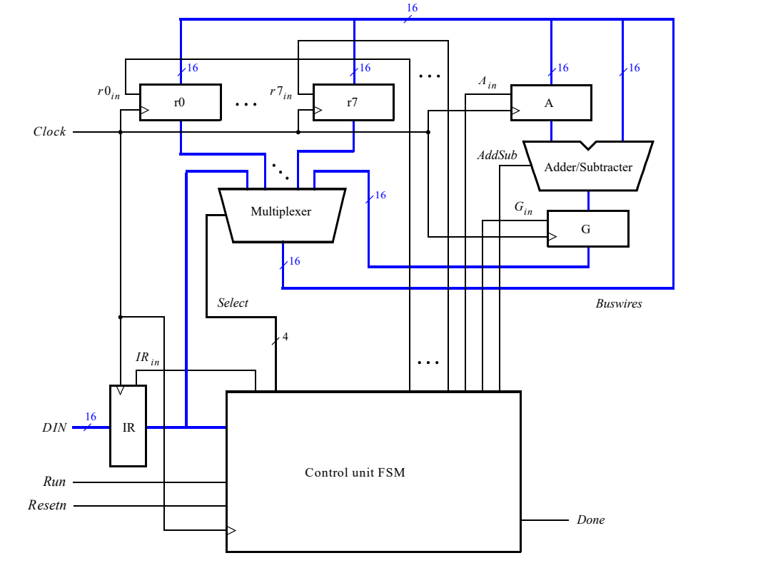

It consists of **Multiplexer**(MUX), **Arithmetic Logical Unit**(ALU), **Control Finite-State-Machine**(Control FSM) and **Registers**(Reg).

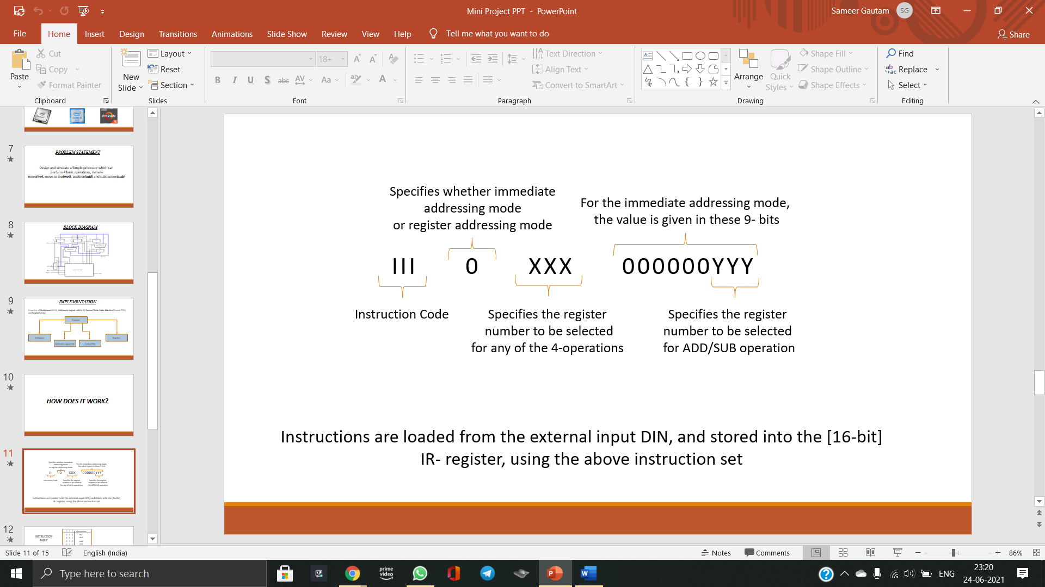Instructions are loaded from the external input DIN, and stored into the [16-bit] IR- register, using the following instruction set:

The system can perform different operations in each clock cycle, as governed by the FSM. It determines when particular data is placed onto the bus wires and controls which of the registers is to be loaded with this data. For example, if the FSM selects r0 as the output of the bus multiplexer and also asserts Ain, then the contents of register r0 will be loaded on the next active clock edge into register A. Addition or subtraction of signed numbers is performed by using the multiplexer to first place one 16-bit number onto the bus wires, and then loading this number into register A. Once this is done, a second 16-bit number is placed onto the bus, the adder/subtracter performs the required operation, and the result is loaded into register G. The data in G can then be transferred via the multiplexer to one of the other registers, as required.

Although only two bits are needed to encode our four instructions, we are using three bits because other instructions might be needed for more operations. Assume that III = 000 for the mv instruction, 001 for mvt, 010 for add, and 011 for sub. Some instructions, such as an add or sub, take a few clock cycles to complete, because multiple transfers have to be performed across the bus. The finite state machine in the processor “steps through” such instructions, asserting the control signals needed in successive clock cycles until the instruction has completed. The processor starts executing the instruction on the DIN input when the Run signal is asserted and the processor asserts the Done output when the instruction is finished.

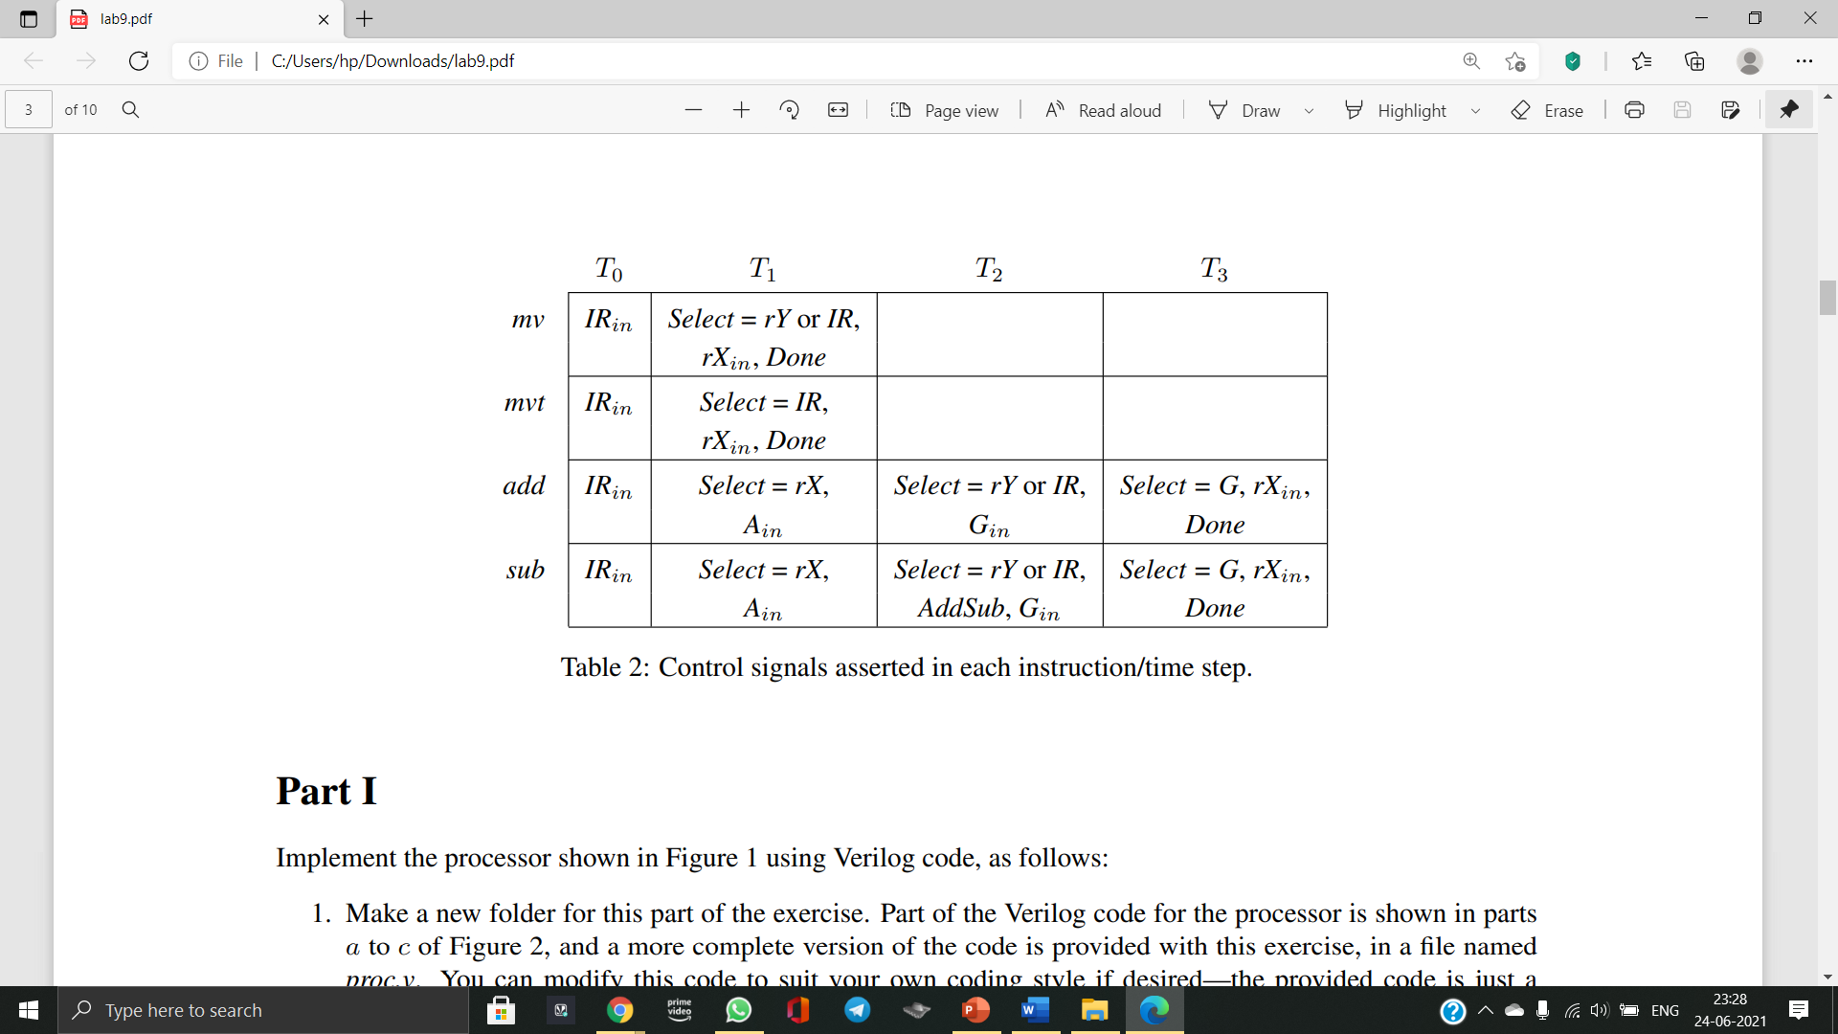

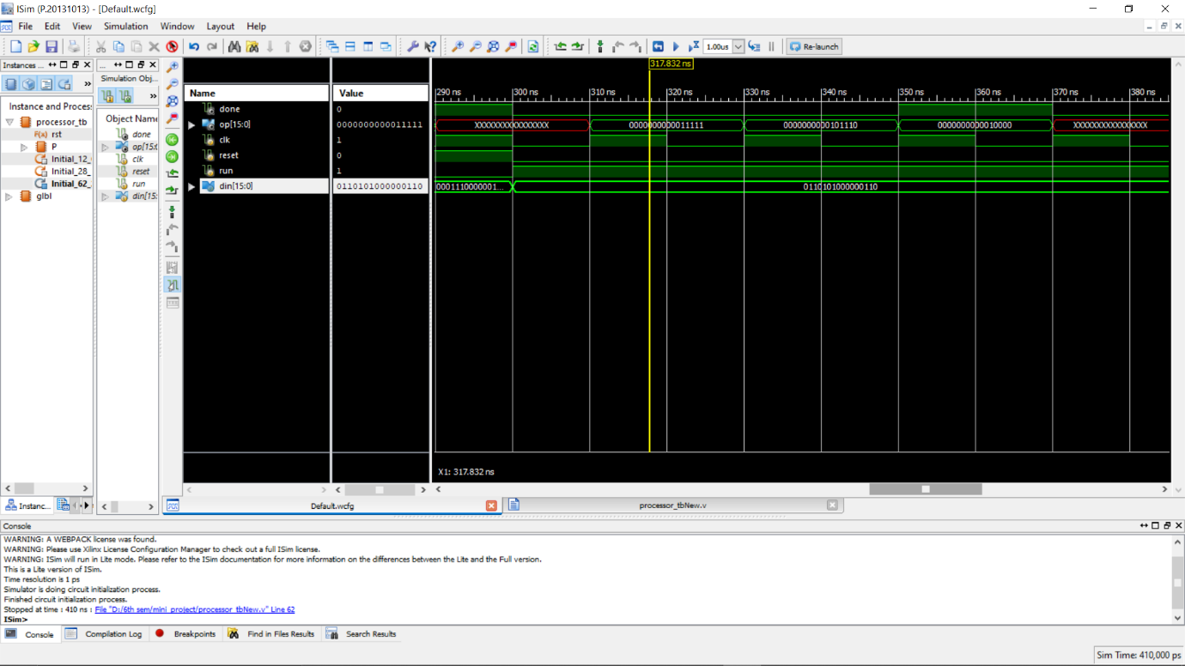**CHAPTER 5: RESULT AND DISCUSIONS**

Fig 1: using mv instruction values copied to r5 and r6 register using Immediate Addressing Mode

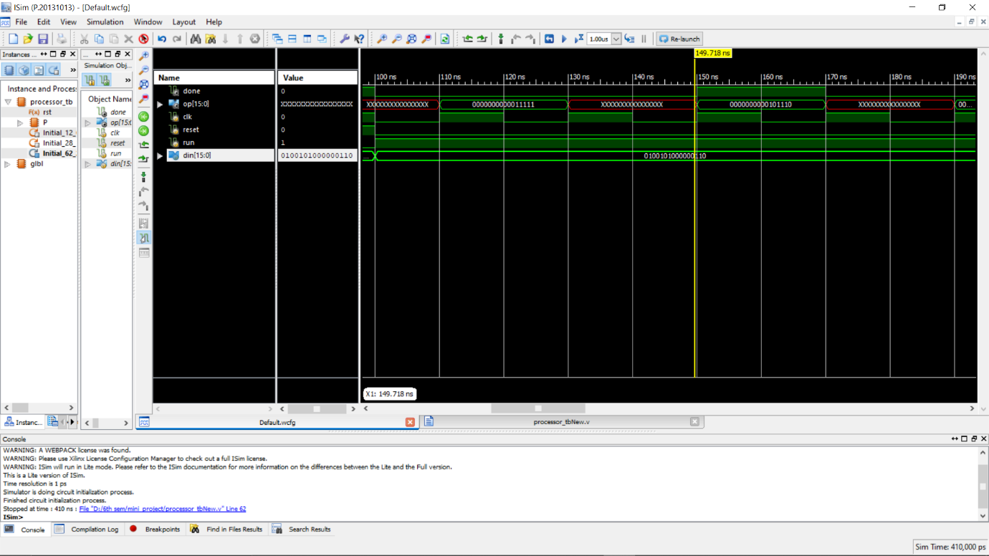

Fig 2: using add instruction values of r5 and r6 register are being added

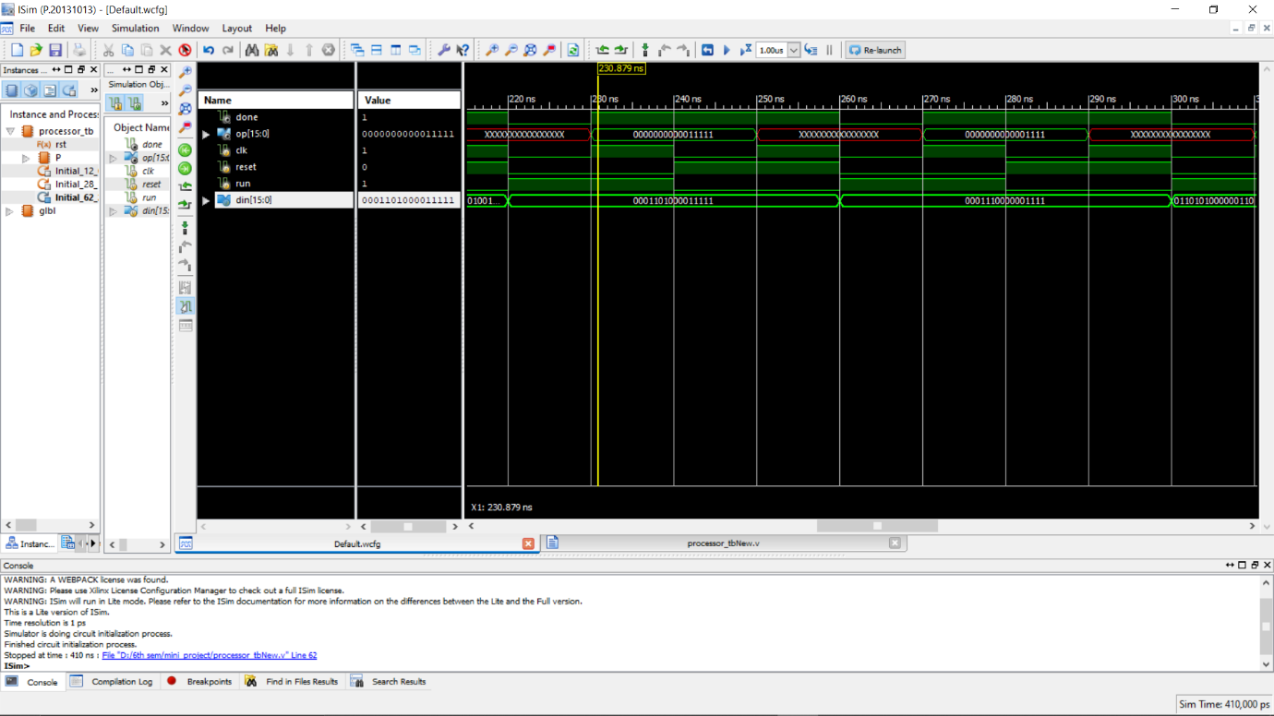

Fig 3: again using mv instruction, values copied to r5 and r6 register using Immediate Addressing Mode

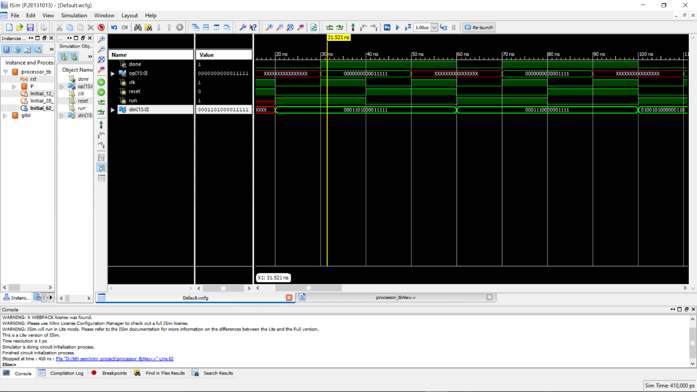

Fig 4: using sub instruction, value of r6 register is being subtracted from value of r5 register.

**RTL SCHEMATIC**

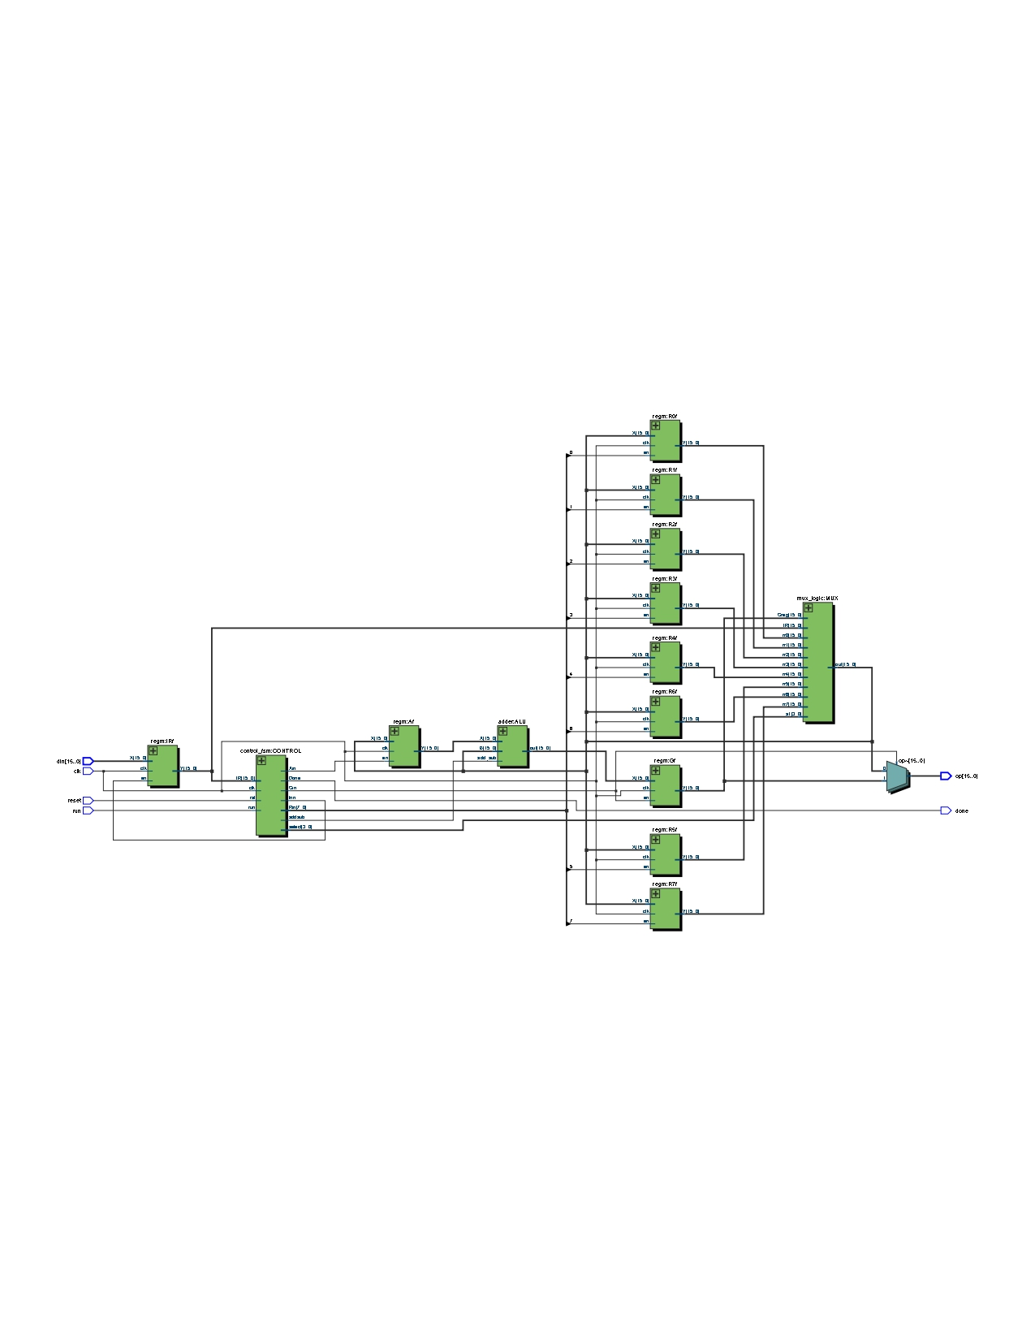

**CHAPTER 6: CONCLUSION AND FUTURE WORK**

**6.1 CONCLUSION:**

This project has explained the methodology of designing a 16 bit basic processor using Verilog language. The implementation of the processor has also been explained along with the simulation results. The major components used in the processor have been exhibited to perform 4 basic operations given by user input. Combining everything, this project explains the implementation of a 16 bit simple processor.

**6.2 FUTURE WORK:**

The module in this simple processor can be integrated with other units to implement an ARM Processor.

**REFERENCES**

1. Andrew N. Sloss, Dominic Symes, Chris Wright “ARM System Developer’s Guide” January, 2004
2. Intel Lab Exercise Manual, Lab Experiment 9
3. www.fpga4student.com